So You have High Cholesterol?
High cholesterol means there is too much cholesterol in your blood. This can clog up your arteries – the large blood vessels that carry blood around your body. Over time, this can lead to serious problems.

There are things you can do to combat this:
Eat Less Fatty Food

If you want to try and reduce your cholesterol try and cut down on the amount of fatty food you are eating, especially food that contains a type of fat called saturated fats.

Simply Put:
Eat more:

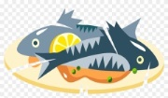
- Oily fish such as Mackerel and Salmon
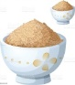
- Brown rice, bread and Pasta
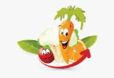
- Nuts and Seeds
- Fruits and Vegetables.
Eat Less:

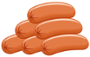
- Meat Pies, Sausages and fatty meat
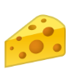
- Butter, lard and ghee
- Cream and hard cheese like cheddar
- Cakes and Biscuits
- Food containing coconut oil or palm oil.
Everything in moderation……….
Exercise:

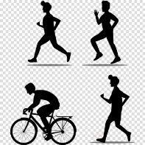
Try to aim to do 2.5hrs of exercise in a week, this can be broken up into manageable sessions, and built up as you progress.

Some good things to do are:
Walking- walking fast enough to make your heart beat faster.
Swimming and Cycling.
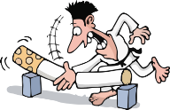
Stop Smoking

Smoking can cause your cholesterol to raise, it makes you more at risk of serious problems such as heart attacks, Strokes and cancer.

We Can offer help with stopping smoking so Please Ask!
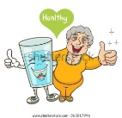
Cut down on Alcohol

Try to:
Avoid drinking more than 14 units of alcohol a week-
A Gin and Tonic is 1u, a normal Pint of Beer is 2u and a Large Glass of wine is 3u, and a bottle of wine is 9u!

